Walk 49 Old Radnor and Hanter Hill
Last walked in October 2018

Description. 7 km (4.3 miles). A fairly strenuous hilly walk along country lanes, across pasture and open hillside.
Start. Church in Old Radnor. Explorer Map 201 Grid 250591.
Direction from Whitecross roundabout (Turn milometer to zero). Take the A438 towards Brecon. At 12.1 miles go straight on, heading towards Rhayader on the A44. At 12.6 miles carry straight on thru Eardisley, heading towards Rhayader. At 18.2 miles go straight across roundabout, head towards Rhayader. Go straight across the next roundabout, (18.5 miles), head for Rhayader. At 22.4 miles you TL for Old Radnor. At 23 miles TL and park-up opposite the church.

1. St Stephen’s Church, Old Radnor. The place-name Radnor refers to ‘a red bank or hill side’ and its earliest authentic occurrence is in the Domesday Book. The parish church of Old Radnor is dedicated to St Stephen to whom there is no other authentic Welsh dedication. Outside the Lych-gate and with you’re back to the church, TR and go down to the main road, (the Old School House is on the L). TL and walk down the main road for about ½ km, to reach a road junction with a minor road going off to the L. Keep to the R and after 40m, TL over a stile/public footpath that’s in a hedge. Go straight down an indistinguishable track that goes steeply down thru bracken, (a stream/small gully is on your R side), to cross a stile/gate into a F1. Continue down F1 to cross another stile/metal gate into F2. A cottage is on your R and you bear L to cross a brook via a wooden footbridge onto a road. TR and a little further on you reach the B4594 main road, (the Crossing Bungalow cottage is on your R). Cross the main road.

2. No Thru Road. Immediately cross over the stile on your R and into F3. TL and walk along the L edge, to cross a stile and footbridge into F4. Bear R across this field to reach the field corner and go thru the R hand gate into F5. Veer very slightly R as you cross this field, you will cross over an aggregate farm track, and then under telegraph wires to go thru a metal gate into F6. Straight across F6 to reach a metal gate, but don’t cross it, TL to cross over a stile that’s up on the L and go into F7. Go under telegraph lines as you go straight up the pasture/field, and go across the stile ahead. Scramble up bank under trees. Go very slightly R to reach a distinct stony farm track. TL then follow the track as it contours right, around Hanter Hill.

3. Track. Carry on up the track to reach a metal gate that’s in front of Touchstone Cottage. Don’t go thru the gate but TL. A little way up you go thru a gate and onto a track, TR (You are now going to do a 2½ km, anticlockwise circle around most of Hanter Hill). Continue gently going up thru bracken and starting to go L with a telegraph line. Go past the markers that are on a telegraph pole(R), that’s just before a farm house (Upper Hanter Farm). Keeping the farm on your R you continue around, with (now) a more clearly defined path. Continue up the path to reach a marker post on the brow of the hill where you TL.
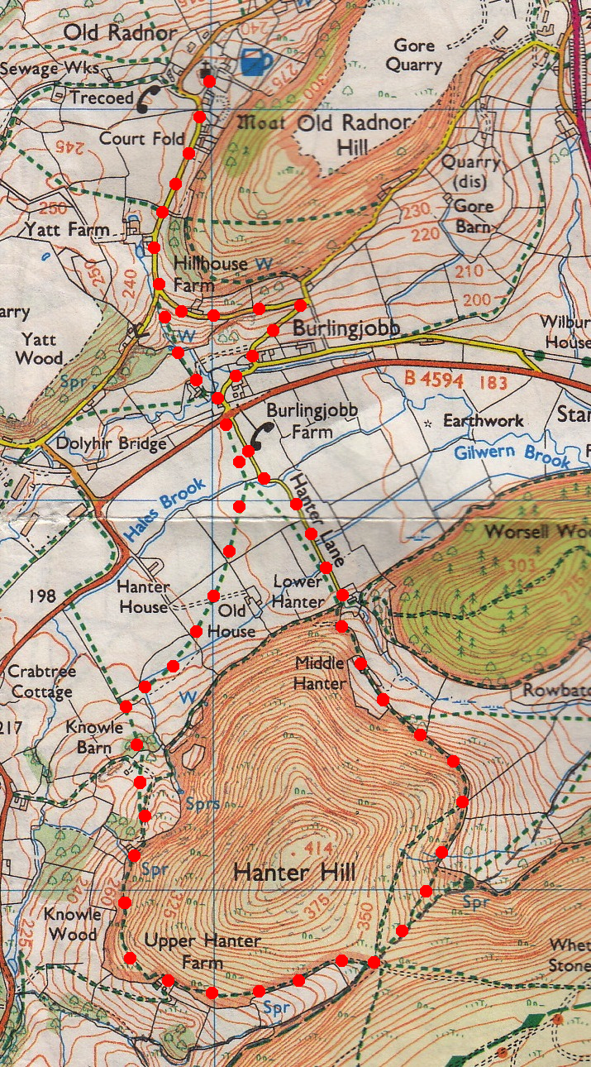
4. Border Post. You are on county and country border here. Go straight ahead along a level path, going past a small marker post (ignore the path going up hill). The path starts going down hill then descends more steeply to meet fence on the R. Continue to drop down past unexpected small group of living huts, thru avenue of trees, and continue on down to reach a T junction below. TR, about 90m to reach a gate that goes into Lower Hunter Farm.
1

5. Lower Hanter Farm. Go thru the gate and TL, go thru another gate and along an enclosed hedged drive, called Hanter Lane. Continue along the lane to to reach the main B4594 road again, go straight across and along a minor road that bend to the R, (Crossing Bungalow cottage is on your L). When the road crosses over a brook you turn immediately L at the road junction. Go up the road to a junction and take the first L, (don’t go up the no thru road that’s in front of you). Continue on up the road and back to the island junction where you TR, continue on up back up to the church.
2

5
4
3

